Spark Streaming and MLlib for Real-Time Boarding Data Analysis

Author: Omkar Pardeshi
Date: 05/02/2025
Course: DATA603 Platforms for Big Data Processing

Table of Contents
1. Introduction
2. System Architecture
3. Methodology
- 3.1 Data Publication with Kafka
- 3.2 Spark Streaming Processing
- 3.3 Machine Learning with MLlib
4. Implementation Details
- 4.1 Kafka Producer Setup
- 4.2 Spark Streaming Consumer
- 4.3 Bus Bunching Detection
- 4.4 Passenger Count Prediction
- 4.5 Anomaly Detection
5. Results & Analysis
6. Literature Review
7. Conclusion & Future Work
8. References
9. Appendix (Screenshots & Code Snippets)

- Introduction
This report documents the implementation of a real-time boarding data analysis system using Apache Kafka for data streaming and Apache Spark (Structured Streaming + MLlib) for processing and predictive analytics.

Problem Statement
Public transportation systems generate vast amounts of boarding data. Analyzing this data in real-time can help:
- Detect bus bunching (multiple buses arriving simultaneously).
- Predict passenger demand at upcoming stops.
- Identify anomalies in boarding patterns.

Objectives
1. Stream boarding data (CSV → Kafka) in real-time.
2. Process data using Spark Structured Streaming.
3. Apply MLlib for predictive and anomaly detection tasks.
4. Analyse highest boarding bustops using live boarding data.

- System Architecture
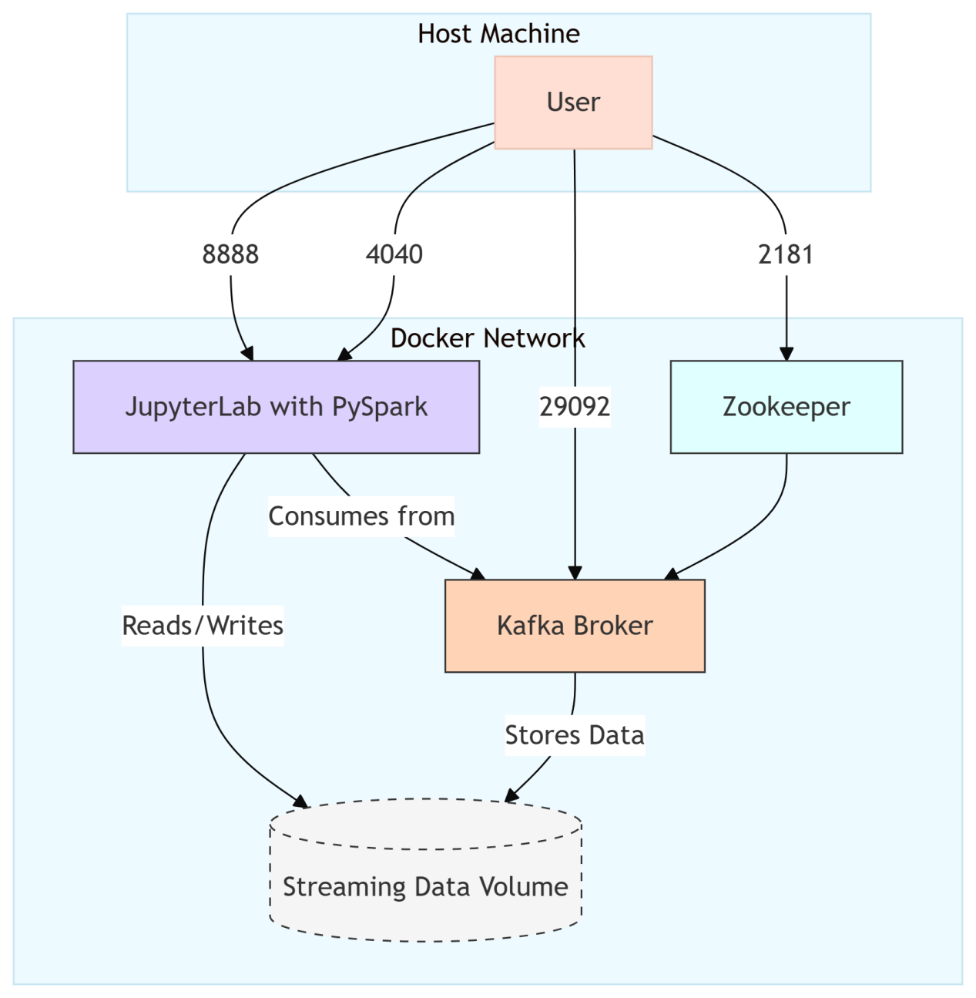
Key Components Explained:

- ed-pyspark-jupyter (A)
  - Image: easewithdata/pyspark-jupyter-lab
  - Purpose: Spark processing and Jupyter notebooks
  - Ports:
    - 8888: JupyterLab interface
    - 4040: Spark UI
  - Volume: Shared /data volume for persistent storage

- ed-zookeeper (B)
  - Image: confluentinc/cp-zookeeper
  - Role: Kafka coordination service
  - Port: 2181 for client connections

- ed-kafka ©
  - Image: confluentinc/cp-kafka
  - Dependencies: Requires Zookeeper
  - Ports:
    - 9092: External Kafka access
    - Internal 29092 for container communication
  - Auto-creation: Pre-configures raw topic

- Shared Volume (D)
  - Named volume streaming_data
  - RW access for both Spark and Kafka containers
  - Stores:
    - Kafka message logs
    - Spark output/checkpoints
    - Sample data files

- Host Access Points
  - All critical ports mapped to host machine
  - Users connect via:
    - localhost:8888 → Jupyter
    - localhost:4040 → Spark UI
    - localhost:9092 → Kafka producers/consumers

- Methodology

- Data Publication with Kafka
- CSV data is streamed via a Python Kafka producer.
- Each row is serialized into JSON and published to a Kafka topic (`boarding-data`).
Key Code:
producer.send('boarding-data', value=row.to_dict())

- Spark Streaming Processing
- Uses Structured Streaming
- Groups data by:
.groupBy(
window("BoardingTime", "10m", "5m"),
"BusStopId",
"RouteId"
)
- Watermarking (`5m`) prevents infinite state accumulation.

- Machine Learning with MLlib
TASK | ALGORITHM | PURPOSE
Bus Bunching Detection | Window Join Functions | Finds buses arriving within 2 minutes
Passenger Prediction | Linear Regression | Forecasts next stop demand
Anomaly Detection | Spark SQL | Flags unusual boarding counts
Top 10 busiest Bustops | Spark SQL | Analyse real-time busiest bustops

- Implementation Details

- Kafka Producer Setup
- Reads CSV in chunks (for large files).
- Simulates real-time delays for realistic streaming.
for _, row in df.iterrows():
record = row.to_dict()
if isinstance(record["BoardingTime"], pd.Timestamp):
record["BoardingTime"] = record["BoardingTime"].isoformat()
producer.send(topic, value=record)
producer.flush()
time.sleep(0.1) # simulate 100 milliseconds intervals

- Spark Streaming Consumer
- Parses JSON into DataFrame with schema:
schema = StructType() \
.add("PassengerId", StringType()) \
.add("BoardingTime", TimestampType()) \
.add("BusStopId", StringType()) \
.add("TripId", StringType()) \
.add("Sequence", StringType()) \
.add("RouteId", StringType())

- Subscribes to Kafka topic.
stream_df = spark \
.readStream \
.format("kafka") \
.option("kafka.bootstrap.servers", "ed-kafka:29092") \
.option("subscribe", "boarding-data") \
.option("startingOffset", "earliest") \
.load() \
.select(from_json(col("value").cast("string"), schema).alias("data")) \
.select("data.*")

- Bus Bunching Detection
Logic:
- Uses window joins to find buses arriving within 2 minutes.
- Saves results to Parquet.
bunching_df = df_with_watermark.alias("a") \
.join(
df_with_watermark.alias("b"),
on=(
(col("a.BusStopId") == col("b.BusStopId")) &
(col("a.RouteId") != col("b.RouteId")) &
(col("a.BoardingTime").between(col("b.BoardingTime") - expr("INTERVAL 2 MINUTES"),
col("b.BoardingTime") + expr("INTERVAL 2 MINUTES")))
)) \
.select(
col("a.BusStopId").alias("BusStopId"),
col("a.BoardingTime").alias("TimeA"),
col("a.RouteId").alias("RouteA"),
col("b.RouteId").alias("RouteB"),
col("b.BoardingTime").alias("TimeB")
).dropDuplicates()

- Passenger Count Prediction
- Features: Hour, DayOfWeek, BusStopId, RouteId.
- Model: `LinearRegression()` from MLlib.
- Training: Runs every 10 minutes on aggregated data.
def train_model(batch_df, batch_id):
if batch_df.count() == 0:
return

print(f"Training on batch {batch_id}...")

# Prepare features
assembler = VectorAssembler(
inputCols=["Hour", "DayOfWeek", "BusStopId", "RouteId"],
outputCol="features"
)
vec_df = assembler.transform(batch_df)

# Train model
lr = LinearRegression(featuresCol="features", labelCol="PassengerCount")
model = lr.fit(vec_df)

# Save or use the model (optional)
model.save(f"models/passenger_model_batch_{batch_id}")
print(f"Model trained and saved for batch {batch_id}.")

# Trigger training for every 10-minute micro-batch
query2 = agg_df.writeStream \
.outputMode("update") \
.foreachBatch(train_model) \
.trigger(processingTime="10 minutes") \
.start()

- Anomaly Detection
- Uses K-Means (k=3) to cluster boarding counts.
- Anomalies = points in the farthest cluster.

# Function for batch anomaly detection
def detect_anomalies(batch_df, batch_id):
from pyspark.sql.functions import mean, stddev

# Aggregate in this batch: group by window and BusStopId
agg_df = batch_df.groupBy(
window(col("BoardingTime"), "10 minutes"),
col("BusStopId")
).count().withColumnRenamed("count", "boarding_count")

# Compute mean and stddev across bus stops in the batch window
stats_df = agg_df.agg(
mean("boarding_count").alias("mean_count"),
stddev("boarding_count").alias("std_dev")
).collect()[0]

# Extract stats
mean_count = stats_df["mean_count"]
std_dev = stats_df["std_dev"]

if std_dev is None or std_dev == 0:
print("No variation in data this batch.")
return

# Calculate z-score and filter anomalies
result_df = agg_df.withColumn(
"z_score", (col("boarding_count") - mean_count) / std_dev
).filter(col("z_score") > 3)

print(f"==== Detected Anomalies in Batch {batch_id} ====")
result_df.show(truncate=False)

# Stream with foreachBatch
query = watermarked_df.writeStream \
.outputMode("append") \
.foreachBatch(detect_anomalies) \
.start()

query.awaitTermination()

- Top 10 Bustops
top_bus_stops_df = stream_df.groupBy("BusStopId").count()

# Write to memory table for visualization
query2 = top_bus_stops_df.writeStream \
.limit(10) \
.outputMode("complete") \
.format("memory") \
.trigger(processingTime = "5 minutes") \
.queryName("top_bus_stops3") \
.start()

- Lowest or Delayed Boardings
# Apply watermark and time window to detect stops with no passenger activity
boardings_windowed = parsed_df.withWatermark("BoardingTime", "5 minutes") \
.groupBy(
window(col("BoardingTime"), "5 minutes", "2 minutes"),
col("BusStopId"),
col("RouteId")
).agg(count("PassengerId").alias("boarding_count"))

# Filter for stops with 0 or low boardings (e.g., possible delays)
delayed_stops = boardings_windowed.filter(col("boarding_count") < 2)

# Output results to console (or can be saved to DB/alert system)
query5 = delayed_stops.writeStream \
.outputMode("append") \
.format("console") \
.option("truncate", False) \
.start()

- Results & Analysis
- Bus Bunching Detection
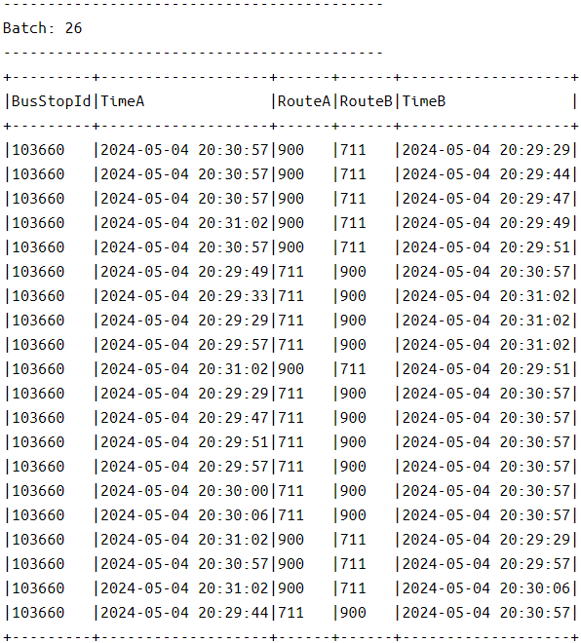

- Passenger Prediction
- Predictions help optimize bus scheduling.

- Anomaly Detection
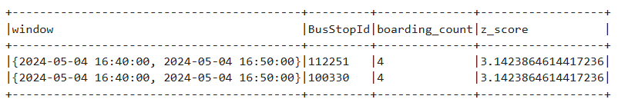

- Top 10 Busiest Bustops
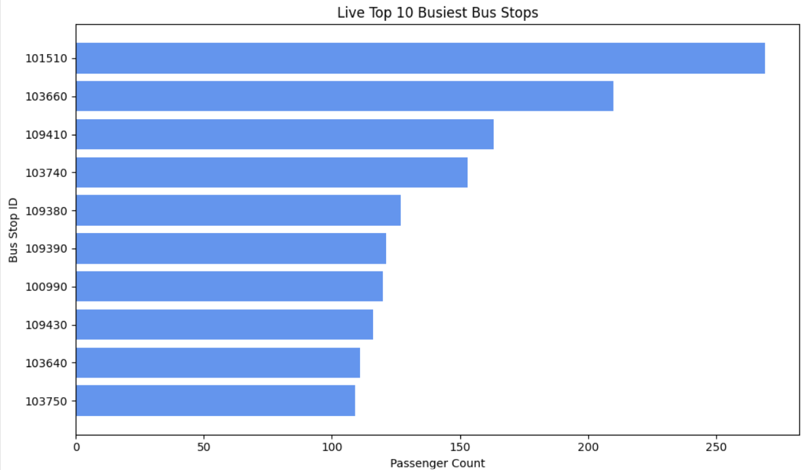

- Missed or Delayed Bustops

- Conclusion & Future Work
Achievements
✅ Real-time streaming pipeline (Kafka + Spark).
✅ Implemeneted analytical models for transportation insights.

Future Work
- Add deep learning for demand forecasting.
- Integrate real-time dashboards (Grafana).

- References
1. Apache Spark Documentation.

